**EVALUATING DEEP LEARNING METHODS FOR CLASSIFYING BUGS**

**BTECH. PROJECT-II REPORT**

SUBMITTED IN PARTIAL FULFILMENT OF THE REQUIREMENTS FOR THE AWARD OF THE DEGREE

OF

BACHELOR OF TECHNOLOGY IN

## SOFTWARE ENGINEERING

Submitted by:

## Deepanshu Singhaniya (2K19/SE/033)

## Aryan Singh (2K19/SE/019)

Under the supervision of:

**Prof. (Dr.) Ruchika Malhotra**



**DEPARTMENT OF SOFTWARE ENGINEERING**

**DELHI TECHNOLOGICAL UNIVERSITY**

(Formerly Delhi College of Engineering) Bawana Road, Delhi - 110042

May 2023

Delhi Technological University (Formerly Delhi College of Engineering) Bawana Road, Delhi - 110042

**CANDIDATE’S DECLARATION**

We, Deepanshu Singhaniya (2K19/SE/033) & Aryan Singh (2K19/SE/019), students of B.Tech. (Software Engineering), hereby declare that the project Dissertation titled “ EVALUATING DEEP LEARNING METHODS FOR CLASSIFYING BUGS” which is submitted by us to the Department of Software Engineering, Delhi Technological University, Delhi in Partial fulfillment of the requirement for the award of the degree of Bachelor’s of Technology, is original and not copied from any source without proper citation. This work has not previously formed the basis for the award of any Degree, Diploma Associateship, Fellowship or other similar title or recognition.

Place: Delhi Deepanshu Singhaniya (2K19/SE/033)

Date: 01/05/202 Aryan Singh (2K19/SE/019)

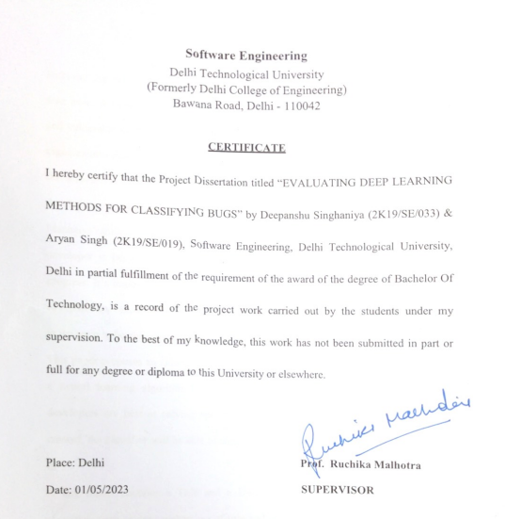

## ABSTRACT

Software maintenance is a crucial part of software development, especially now more than ever. Without proper maintenance, software can become outdated and unreliable and vulnerable to security threats, which can have serious consequences for users and organizations that rely on it. But as the software projects become larger, it becomes It is the responsibility of the managers to assign the bugs to the developers so that the developers can use their time efficiently in resolving those bugs. But the capacity of Managers’ ability to analyze each and every bug report and assign it to the appropriate developer is being out-paced by the sheer number of bug reports, leading to slow progress. It’s impossible for developers or managers to be able to understand hundreds of reports a week, let alone being able to have a good idea of each and every developer in the team to be able to appropriately assign the bugs to them.

This paper proposes an automated approach to help with the problem. Our method uses a neural learning algorithm to analyze the open bug database and learn which developers are best at solving specific types of bug reports. When a bug report is created, the classifier will be able to suggest a few developers who would be able to fix it.

A bug report contains a Title and a Description, An automatic bug classification algorithm such as ours makes use of title and description of the bug reports as inputs and assigns it to any of the accessible developers using the data about previously solved bugs of that particular developer. The main issue that poses a challenge heterogeneity of the content in bug description, is a mixture of unstructured code snippets, text, and stack traces, which may make the input data very noisy and difficult to interpret.

## ACKNOWLEDGEMENT

We, Deepanshu Singhaniya (2K19/SE/033) and Aryan Singh (2K19/SE/019) would like to thank our supervisor Prof. (Dr.) Ruchika Malhotra for her valuable feedback and timely suggestions during the entire duration of our dissertation work, without which this work would not have been possible. It is not easy to gain the faculty of seasoned and highly acclaimed scholars who can vouch for and guide your work, and we are eternally grateful to have the honor of working on our final dissertation under Prof. Ruchika. Not only did Prof. Ruchika help us stay on track with respect to the project delivery timeline, but also sat through each session of editing with us. She has painstakingly invested his time and energy even much beyond the office hours in order to support us, and this work could not have been completed without reaching a standard level of research quality without her valuable guidance. We would like to convey our most sincere regards to all faculty members and distinguished scholars of the Department of Software Engineering, who lent us their time, resources, knowledge and efforts unconditionally and wholeheartedly. This work is truly built upon the efforts that were lent to us by all the well-meaning scholars who assisted us in finding and curating the requisite knowledge from reputable sources, helped annotate our document so that we can eliminate any unintended plagiarism, and also mentored us in the technologies and tools we wished to adopt in order to execute this project.

## Deepanshu Singhaniya Aryan Singh

## 2K19/SE/033 2K19/SE/019